**Auditory Cortical Reorganization Following Cochlear Implantation in Children with Prelingual Profound Hearing Loss: An fNIRS Study**

**Presenting Author- Dr Arun Srinivaasan S**

**Co authors- Dr Kranti Bhavana, Dr. Kamlesh Jha, Dr Vijay Kumar, Dr Govind Bhuskute .**

**Introduction:**  
Prelingual hearing loss significantly impacts language acquisition and cognitive development in children. Cochlear implantation (CI) is the treatment of choice in auditory rehabilitation for prelingual severe to profound hearing loss patients who are unable to gain sufficient benefit from appropriate and well – fitting hearing aids with a functional cochlear nerve and a well-formed cochlea. However, the underlying neural mechanisms of auditory recovery remain incompletely understood. Functional near Infrared Spectroscopy (fNIRS) enables non-invasive auditory cortical mapping, presenting a unique opportunity to monitor post-implantation cortical neuroplasticity.

**Aim:**  
This study aims to assess the effects of CI on auditory cortical reorganization in prelingually profound hearing loss children using fNIRS, thereby elucidating the neural correlates of auditory recovery and informing clinical strategies for optimal rehabilitation.

**Methodology:**  
A cohort of 12 prelingually hearing-impaired children of including preop, 1 year post op CI and 2 year post op CI were enrolled between June 2024 and dec 2024 after an IEC approval (AIIMS/Pat/IEC/2024/7). fNIRS was employed to measure the auditory cortical activation for visual stimulus, Puretone auditory stimuli of 250 Hz , 1kHz, 6KHZ, and speech stimulus. both pre- and post-implantation . Data analysis focused on changes in activation intensity and spatial distribution within primary auditory cortices, using multivariate analysis the Kruskal Wallis test to identify significant differences among the groups

**Results:**  
We had children of the preschool and the early school going age participate in our study. Preliminary findings indicate a marked increase in auditory cortical activation post-implantation groups. Enhanced activation correlated strongly with improved behavioural auditory perception scores- MAIS scores.

The comparison of Bilateral TotalHb, Bilateral OxyHb in Auditory cortex for 250Hz stimulus, Right OxyHb, Bilateral TotalHb in Auditory cortex to 1KHz, Bilateral TotalHb and Bilateral OxyHb in auditory cortex for speech stimulus by Kruskal Wallis test shows a statistically significant difference at p < 0.05 level.

There was also a noticeable increase in auditory cortex stimulation to visual stimulus *without* sound stimulus in the immediate post op period which had decreased in 2 years post speech therapy children.

**Novelty:**  
This study is one among the few to use fNIRS with CI outcome assessment in prelingual children to assess responses of auditory cortices to various stimuli- visual stimulus, 250 Hz stimulus, 1KHZ stimulus, 6KHz stimulus, Speech stimulus offering novel insights into neuroplasticity following auditory rehabilitation. It is a non-invasive approach paves the way for routine clinical monitoring of cortical changes.

**Conclusion:**  
The findings underscore the efficacy of CI in promoting auditory cortical reorganization, highlighting fNIRS as a valuable tool for evaluating and optimizing auditory rehabilitation in prelingually profound hearing loss children.

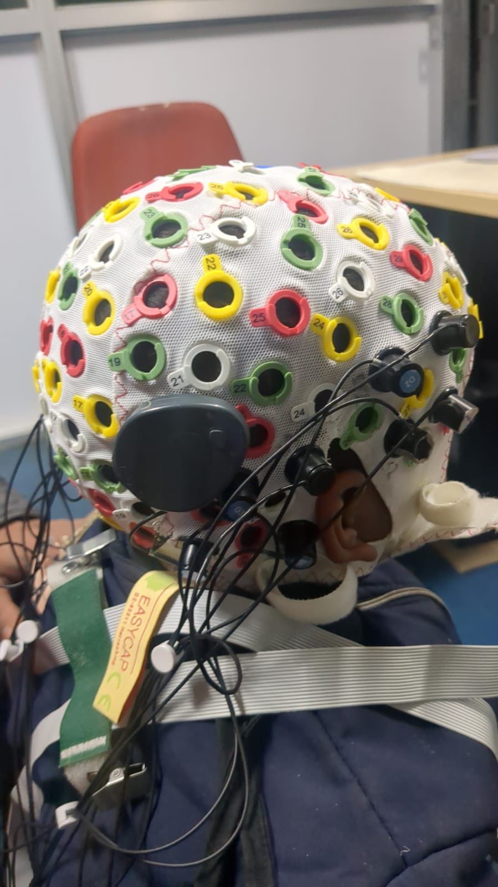

Figure- fNIRS in a cochlear implant child being done at our centre